VPC Peering and Network Resources
Topic: VPCs, subnets, route tables, Internet Gateways and peering connection
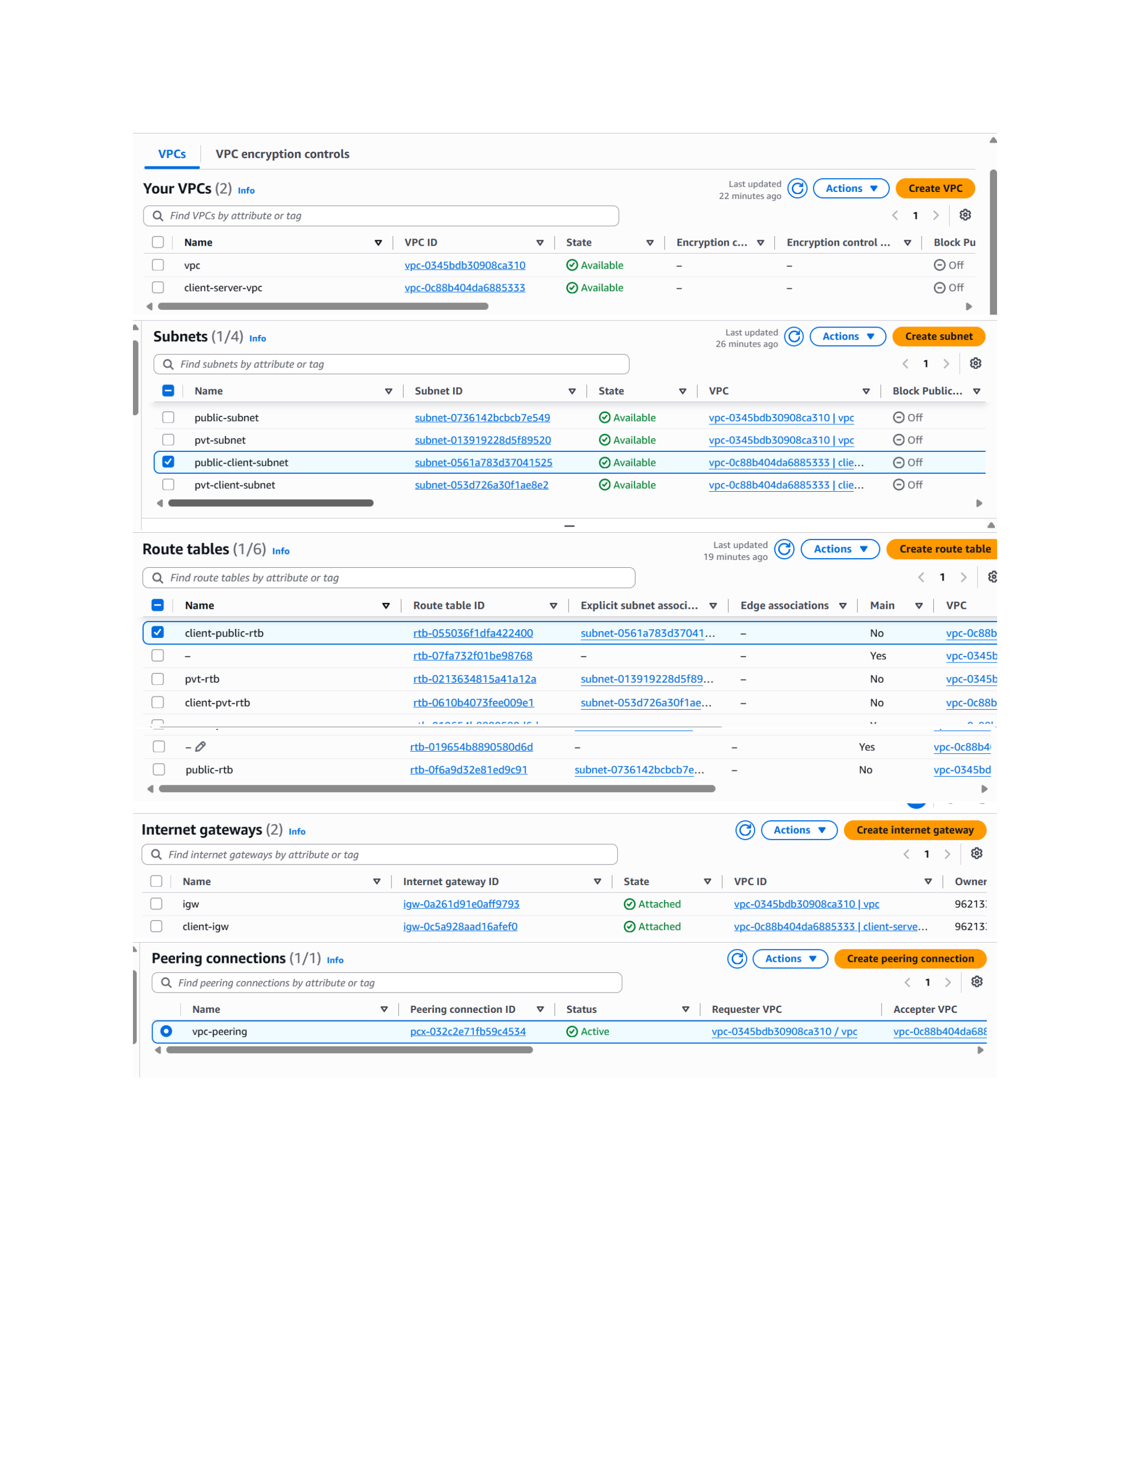
Action: AWS VPC console shows two VPCs with public/private subnets, route tables and Internet Gateways. The peering connection between the VPCs is shown in Active state.

Configure Routes for VPC Peering
Topic: Route-table entries and EC2 instances
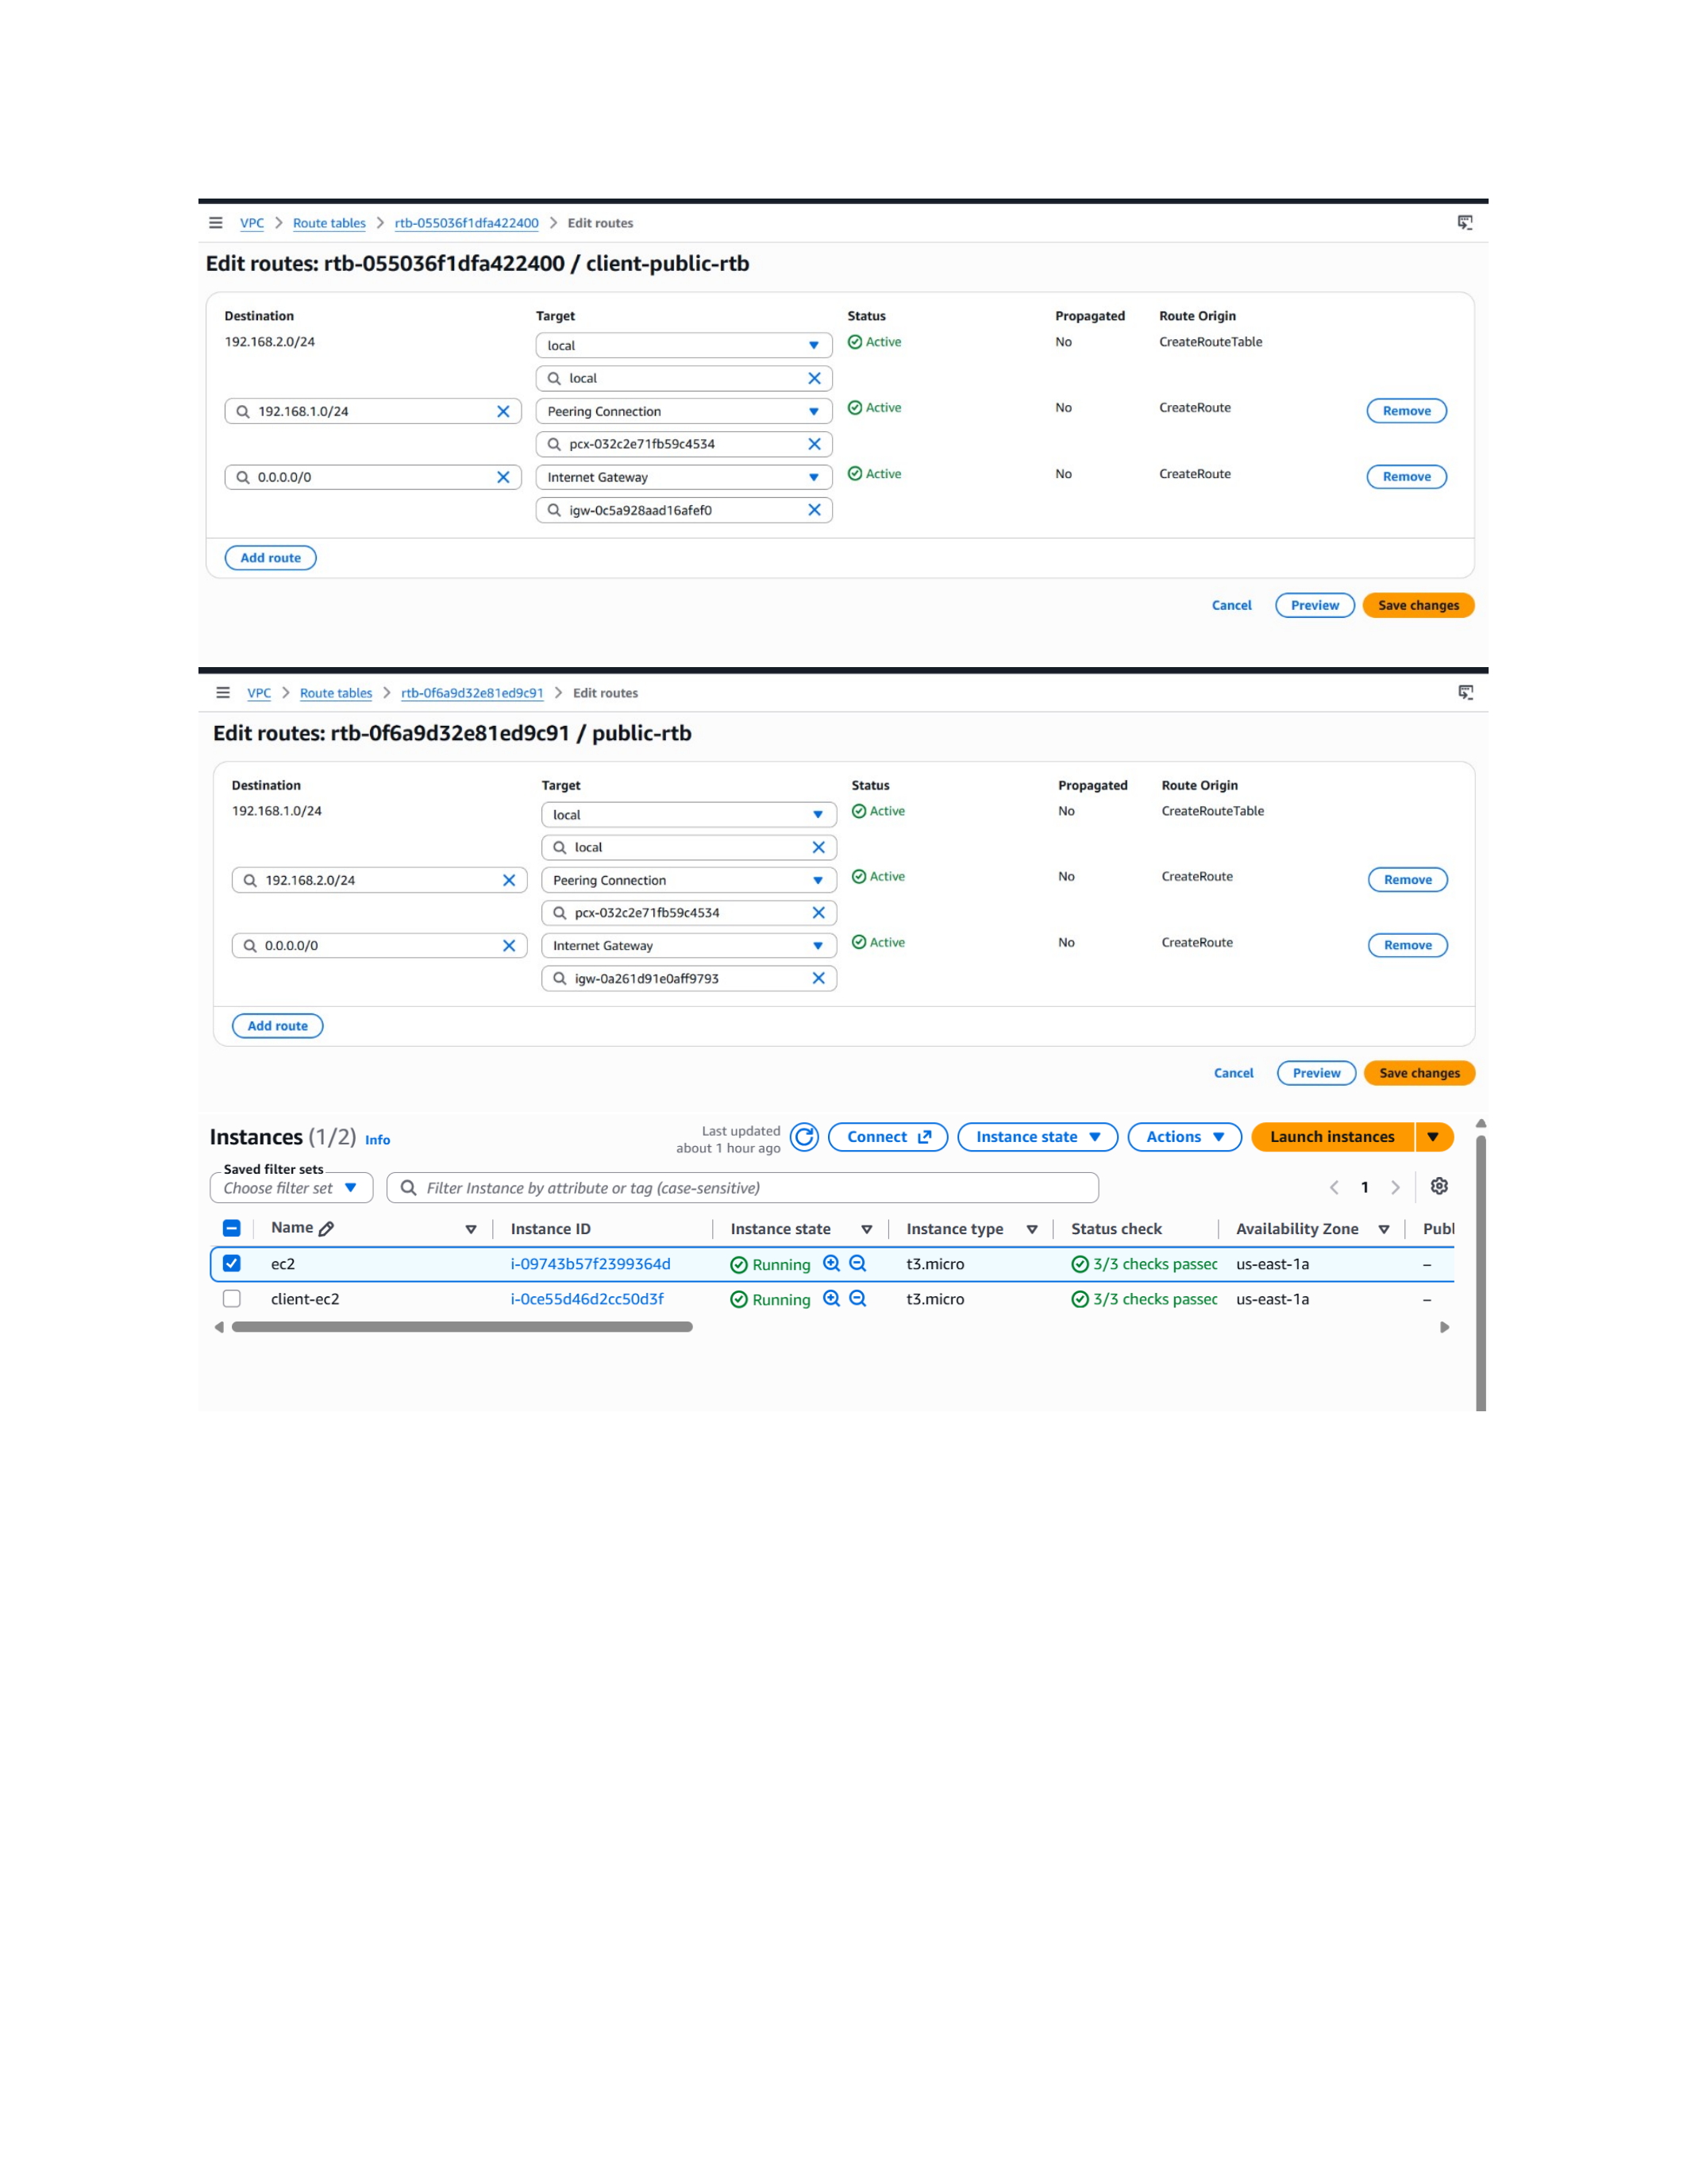
Action: The client-public route table contains a 192.168.107.24 destination through the peering connection, while the public route table shows the peering route. Two EC2 instances are running in the VPCs.

Install the VSFTPD FTP Server
Topic: VSFTPD package installation on Red Hat Enterprise Linux
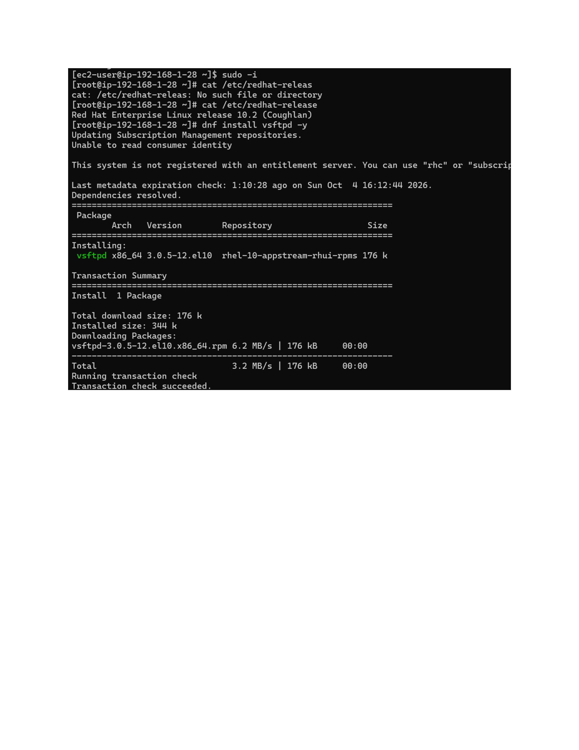
Action: The RHEL 10.2 server installs the vsftpd package with dnf. The package download and transaction complete successfully.

Start and Verify the FTP Service
Topic: VSFTPD service startup and port 21 verification
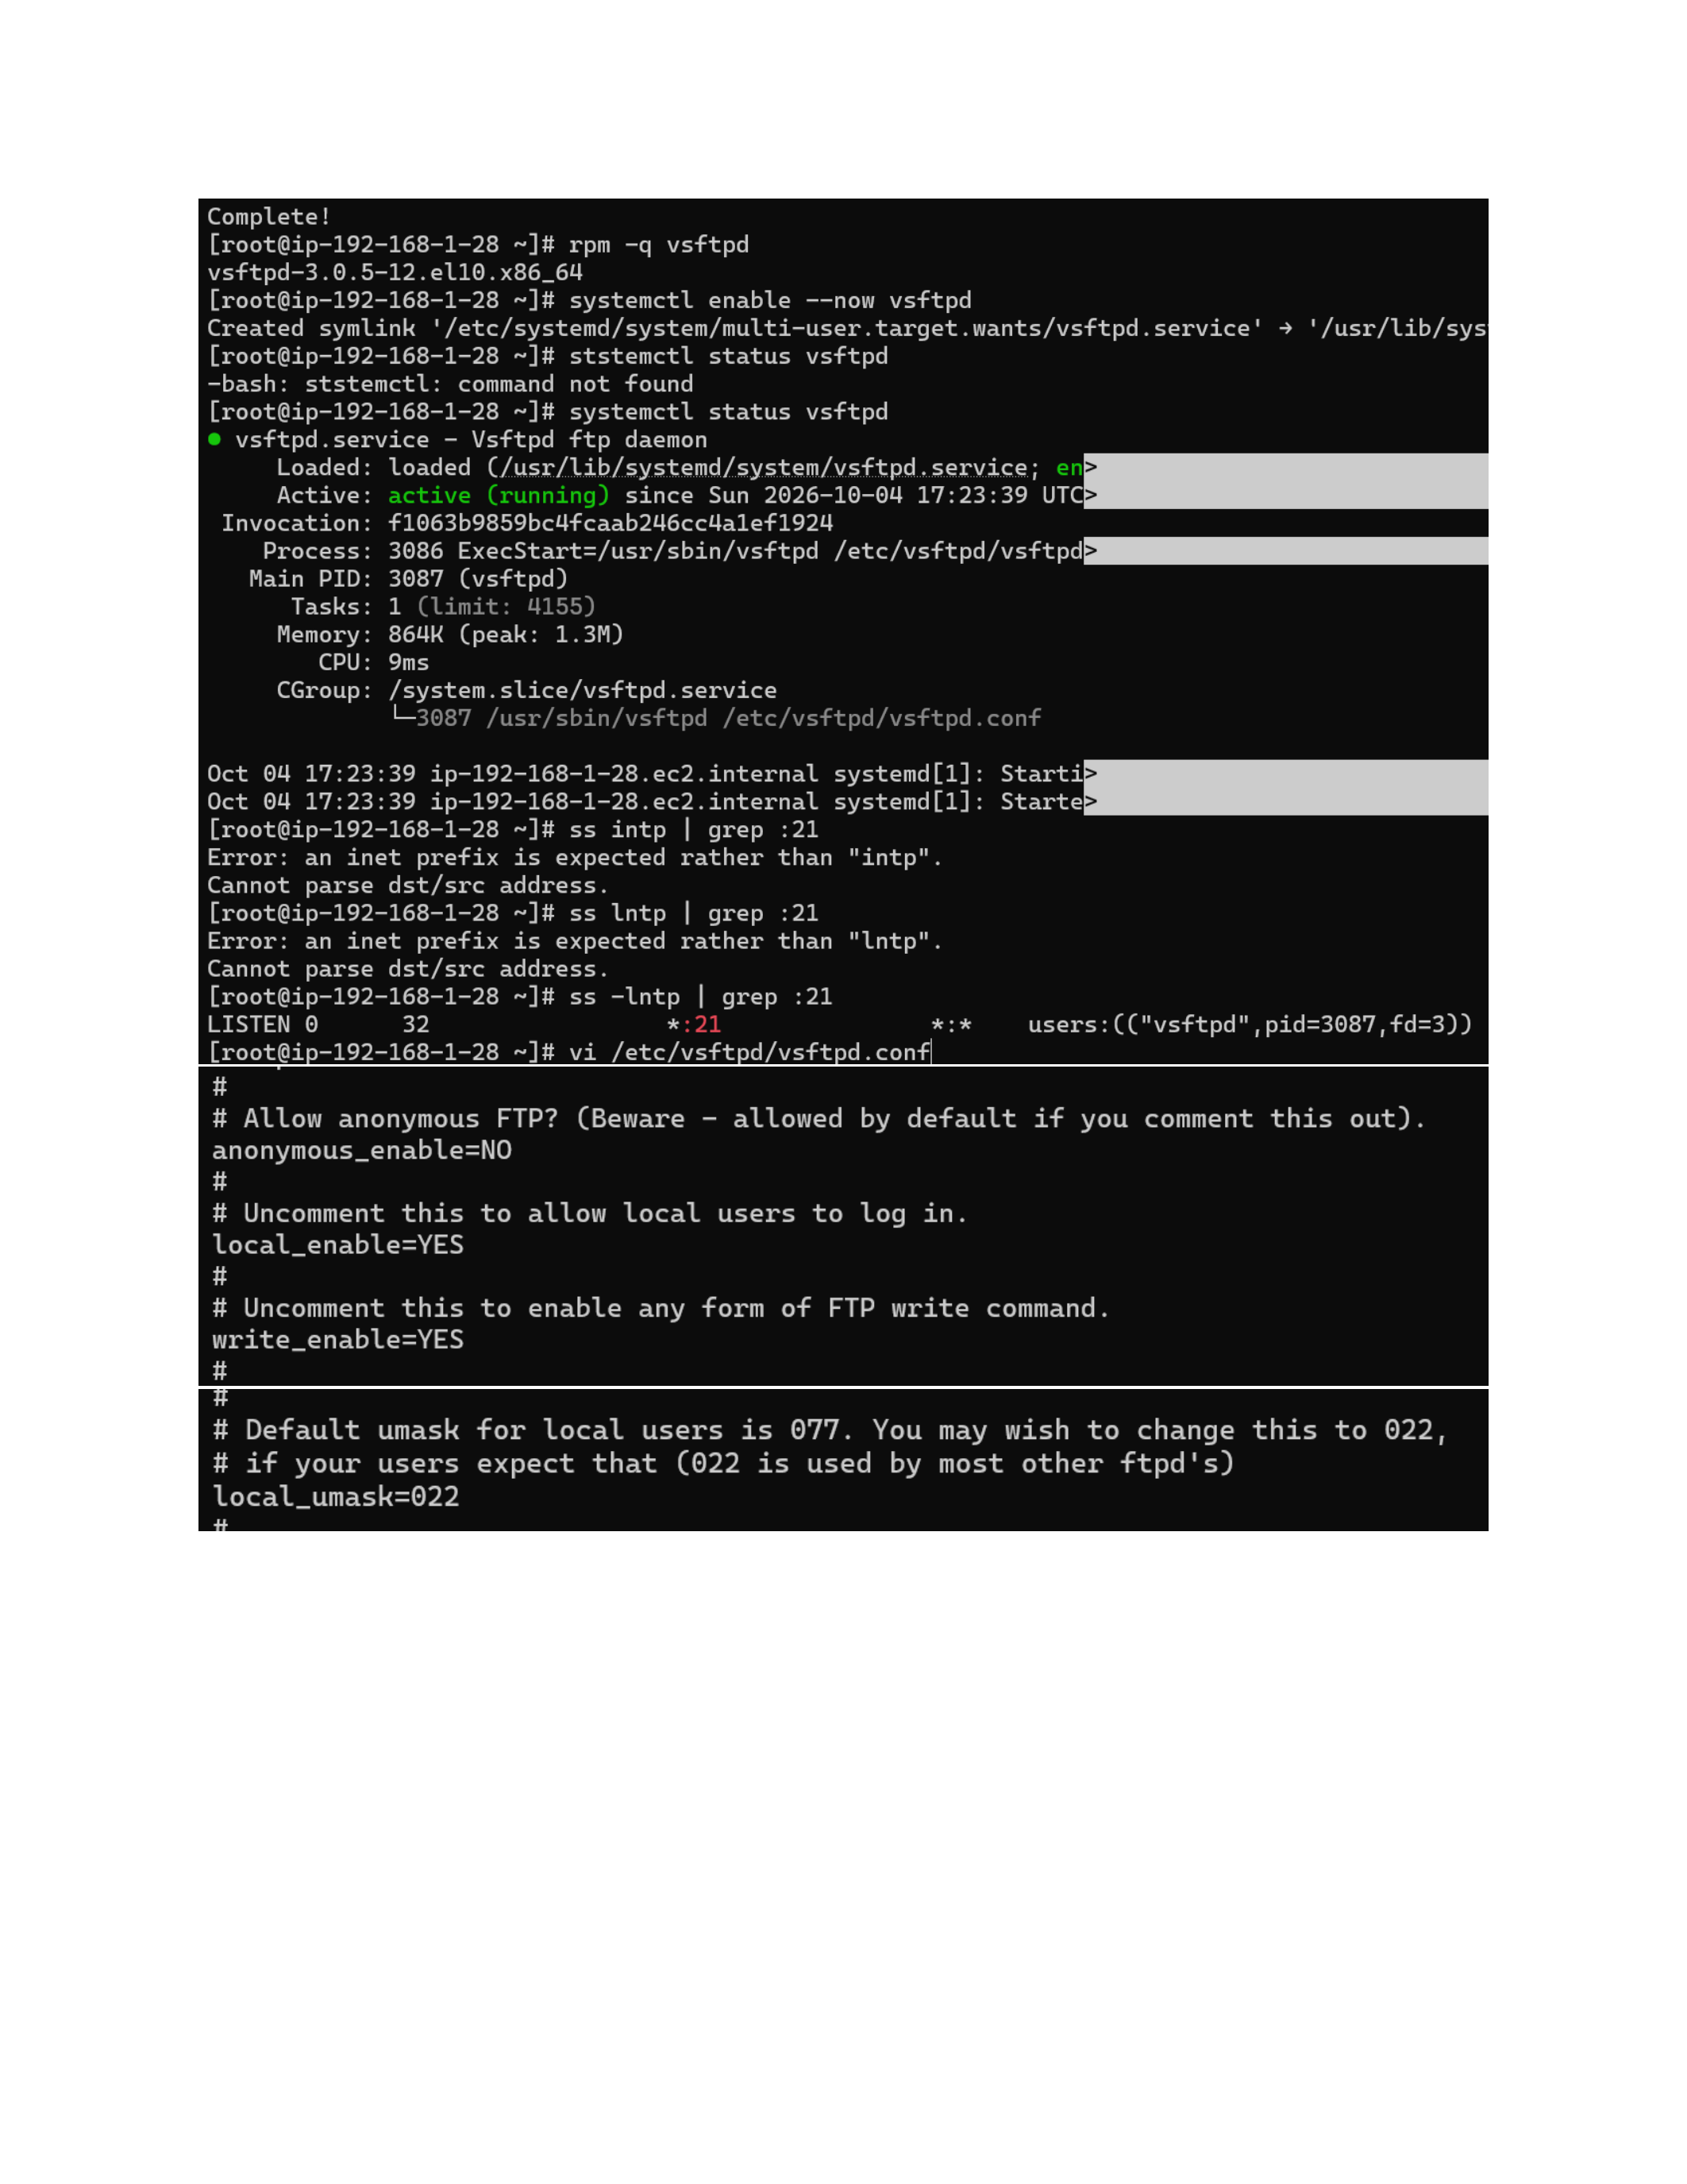
Action: VSFTPD is enabled and started with systemctl. After correcting command typos, systemctl status confirms the service is active and listening on FTP port 21.

Configure VSFTPD for Local Users and Passive FTP
Topic: FTP configuration file and passive-port settings
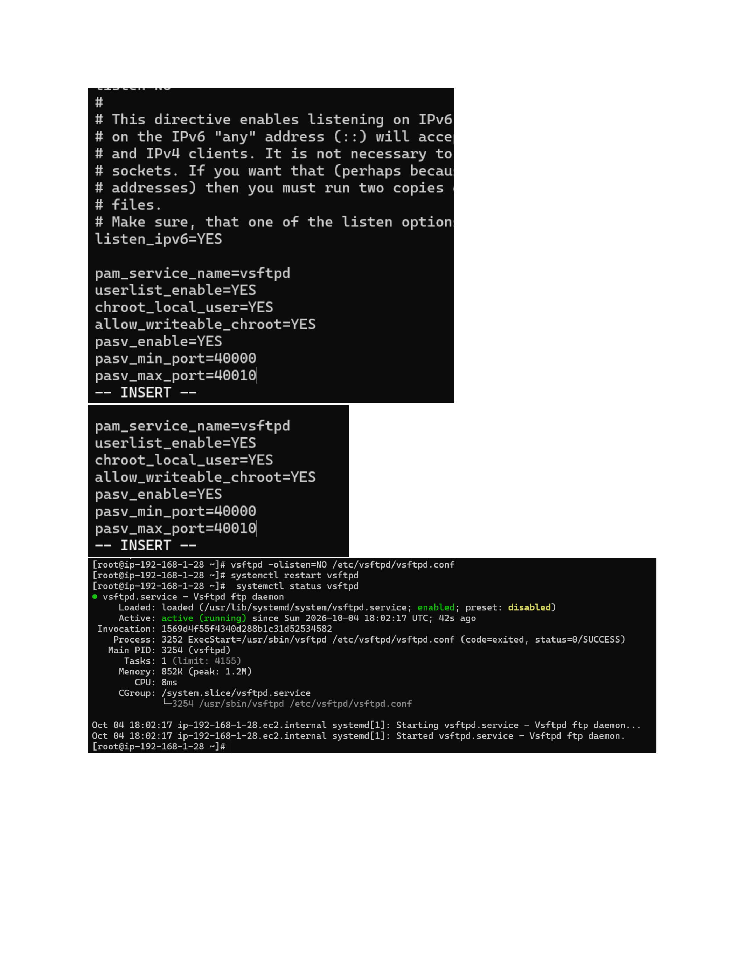
Action: The /etc/vsftpd/vsftpd.conf file is edited to disable anonymous access, allow local users and writes, chroot local users, and configure passive FTP ports 40000-40010. The service is restarted and verified active.

Create FTP User and Open Firewall Ports
Topic: FTP user, server file and firewall rules
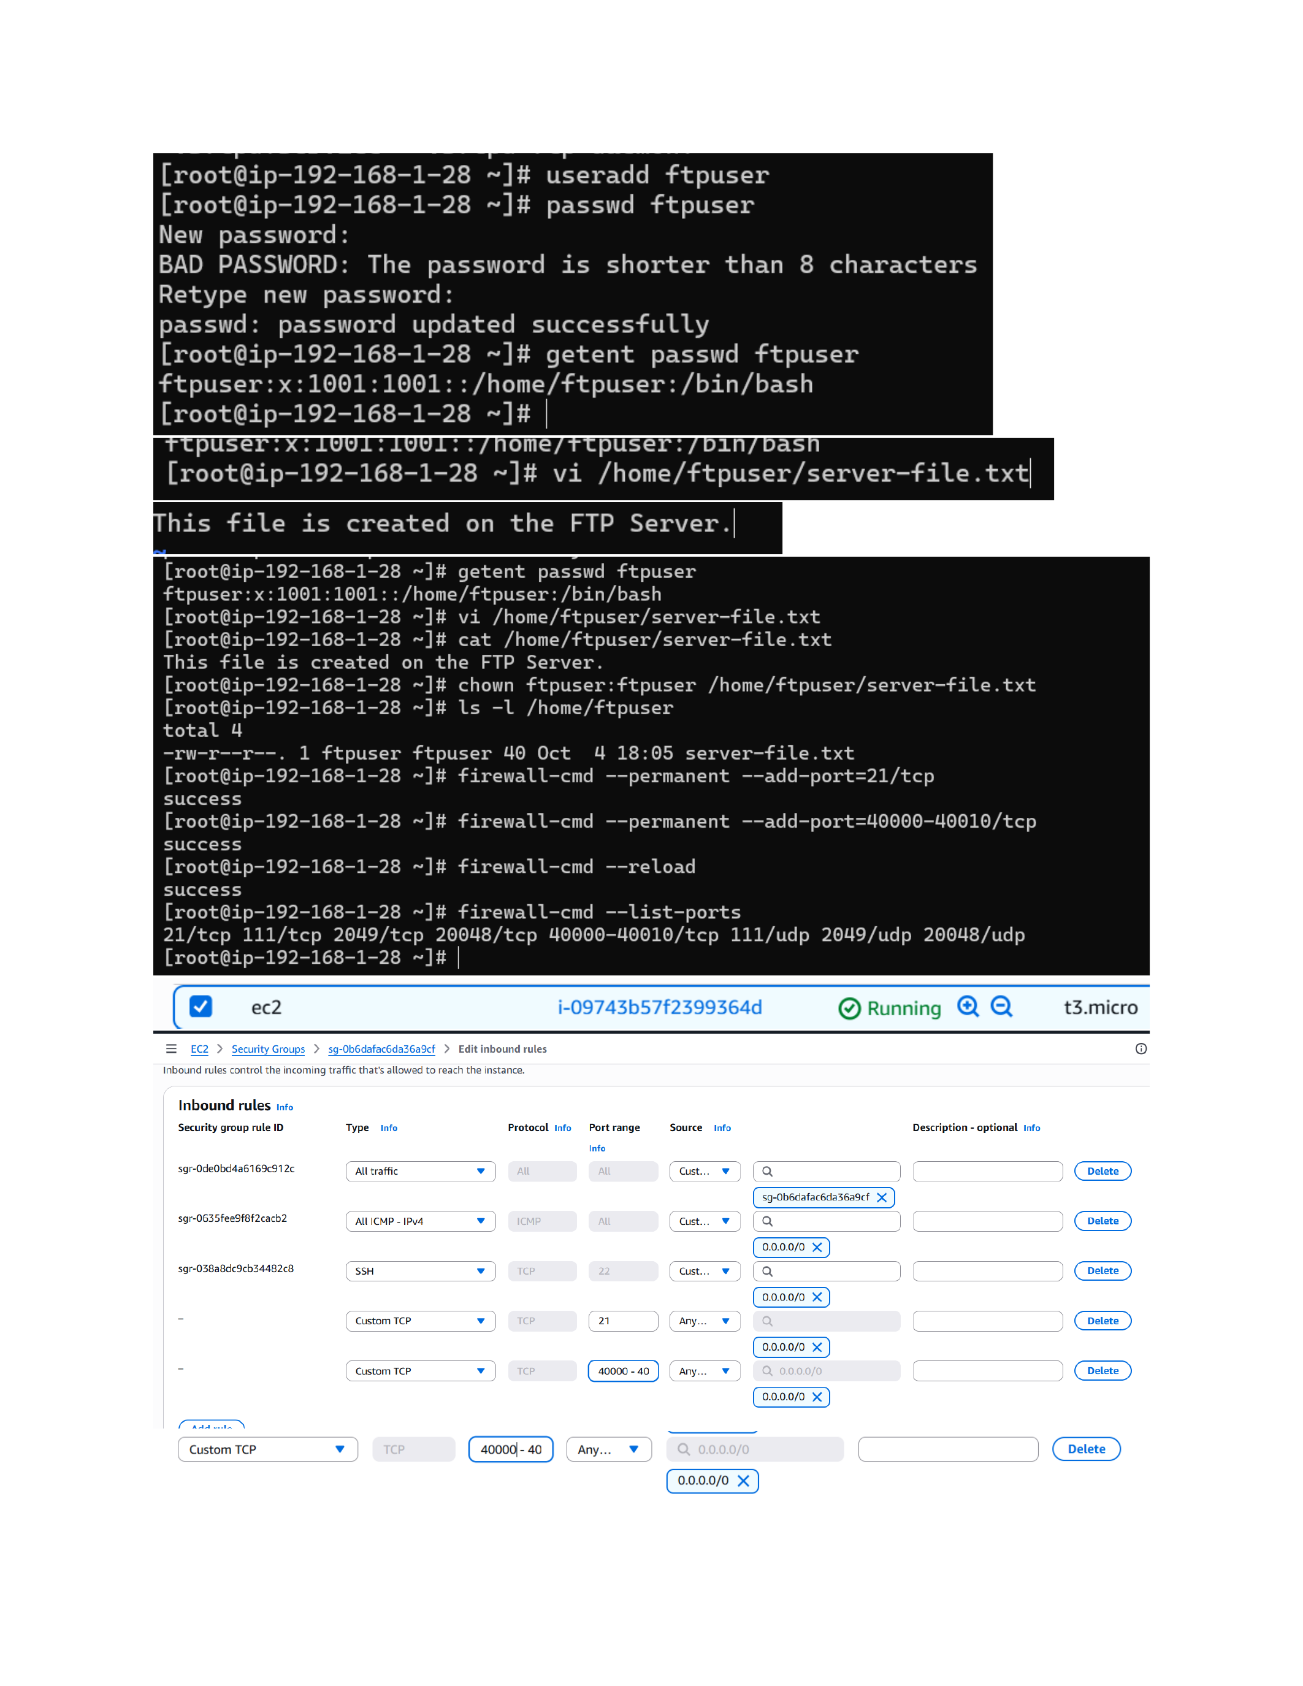
Action: An ftpuser account is created and given a password. server-file.txt is created in the user home directory and ownership is assigned to ftpuser. Firewall ports 21/tcp and 40000-40010/tcp are opened and reloaded; EC2 inbound rules are also configured.

Test FTP Download from the Client
Topic: LFTP connection and server-to-client file transfer
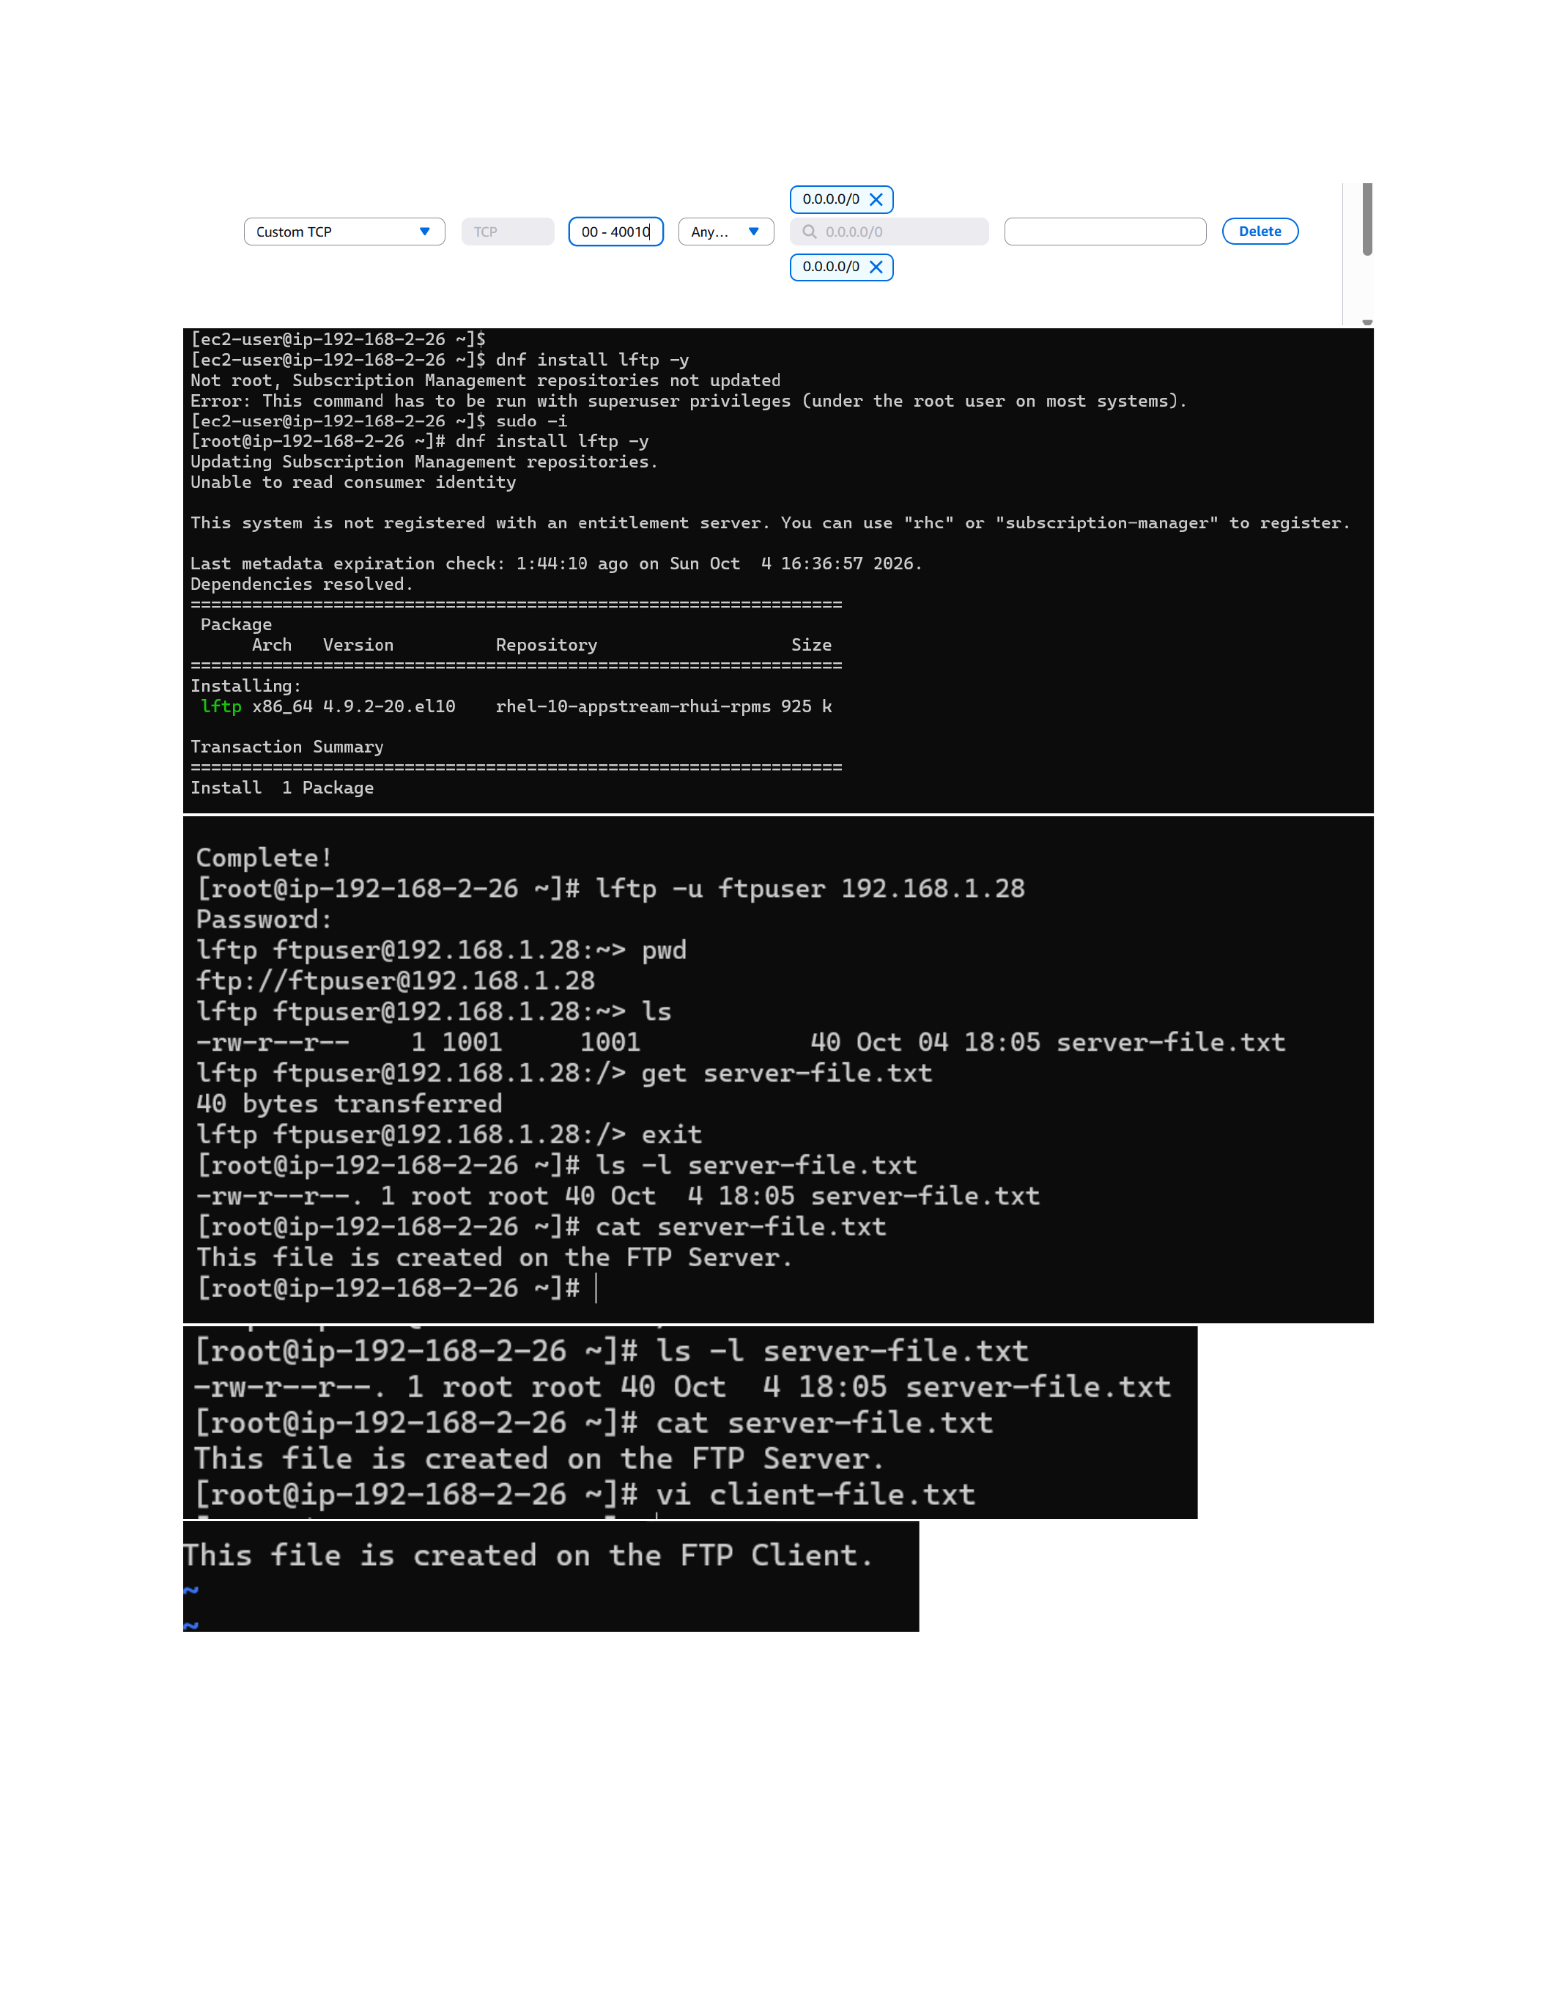
Action: The client connects to 192.168.1.28 with lftp using ftpuser, lists server-file.txt, downloads it successfully, and verifies the downloaded file contains the FTP Server message.

Upload a File from FTP Client to Server
Topic: LFTP upload and server-side verification
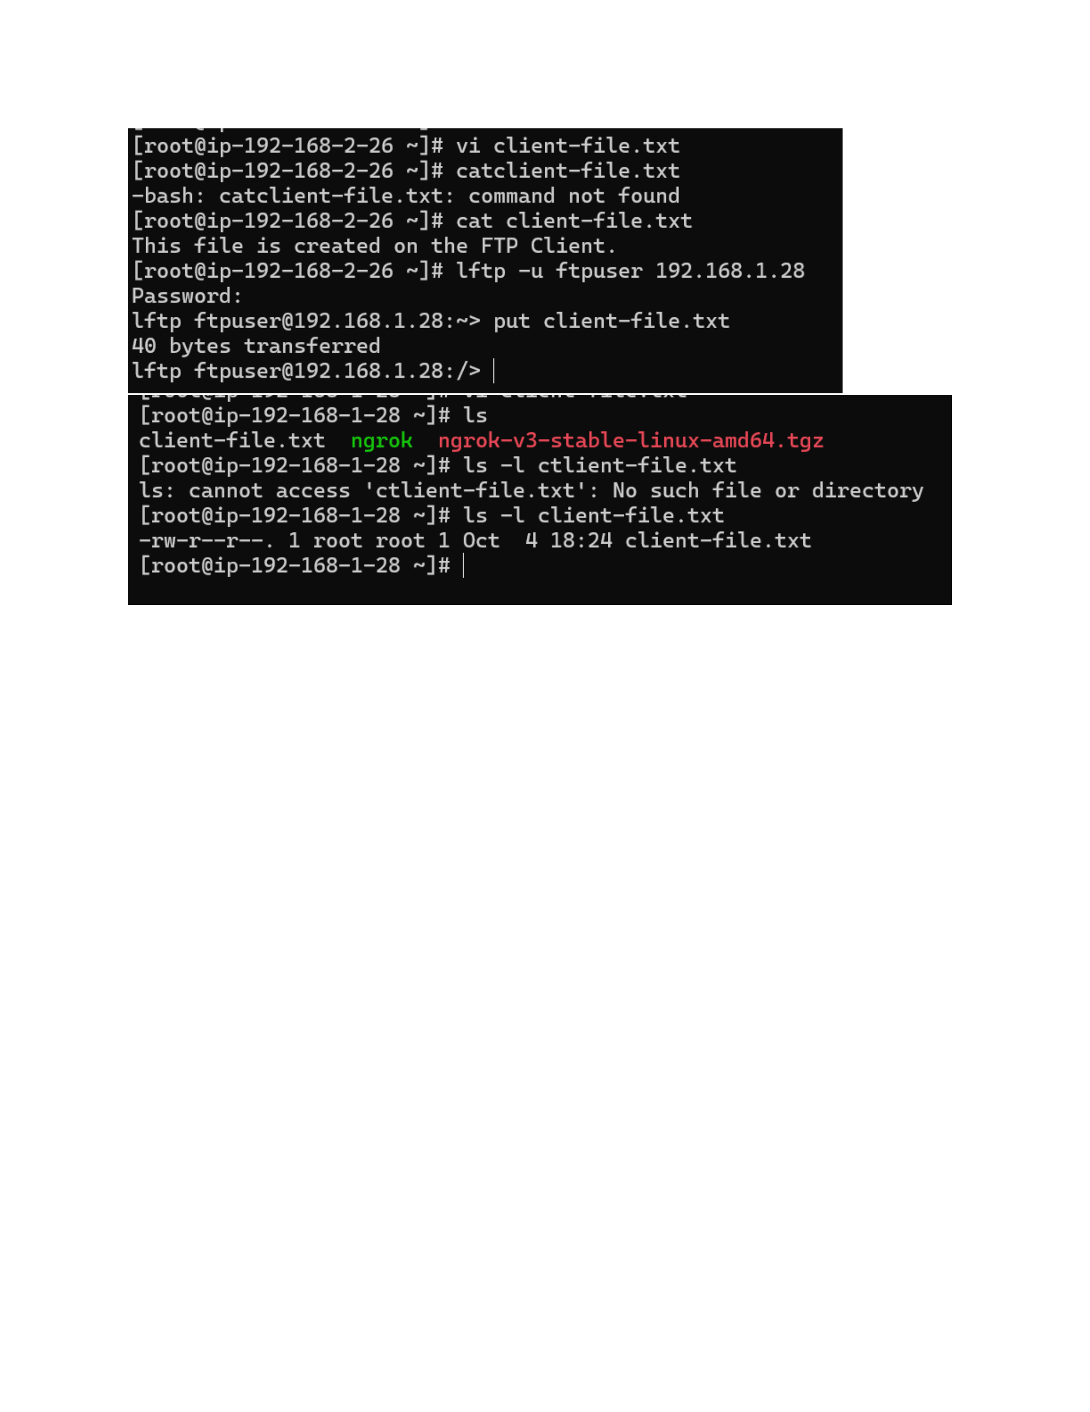
Action: A client-file.txt is created on the FTP client. Using lftp, the file is uploaded to the FTP server, then the server lists the uploaded file and verifies its presence.

